MINI NLP PROJECT
NLP-Based SMS Spam Detection Using TF-IDF and Machine Learning

Submitted by:
Kiran R
Roll Number: 24UBC243
Course: Bachelor of Computer Applications (BCA)
Academic Year: 2024–2028
College: Marian College Kuttikkanam Autonomous

Python | NLP | TF-IDF | Machine Learning | Streamlit

1. Problem Statement
Spam SMS messages are unwanted messages that may contain advertisements, fraudulent offers, prize claims, or misleading information. Manually identifying spam messages can be difficult when the number of messages is large. This project aims to develop an automated Natural Language Processing (NLP) system that classifies SMS messages as either Spam or Ham (legitimate).

2. Objectives
The main objectives of this project are:
To collect and inspect an SMS text dataset.
To preprocess SMS messages using text-cleaning techniques.
To convert text into numerical features using TF-IDF.
To train and compare Machine Learning classification algorithms.
To evaluate the models using accuracy, precision, recall, F1-score, and a confusion matrix.
To save the final trained model and TF-IDF vectorizer.
To develop a simple Streamlit application for real-time SMS classification.

3. Dataset
Dataset: SMS Spam Collection
The project uses the SMS Spam Collection dataset. It contains SMS messages labelled as either Ham or Spam. The original dataset contains 5,572 messages. Duplicate records were removed before model development, resulting in 5,170 messages used for the train-test workflow.
Dataset fields:
label – identifies the message as ham or spam.
text – contains the SMS message.
The dataset was obtained from a public GitHub copy of the SMS Spam Collection dataset.
Limitations of the dataset include its relatively small size, English-language focus, and the possibility that newer spam patterns are not represented.

4. Methodology
The project was implemented through the following workflow:
1. Load the SMS dataset using Pandas.
2. Inspect the shape, labels, data types, and missing values.
3. Remove duplicate records.
4. Convert the text labels Ham and Spam into numerical labels 0 and 1.
5. Clean the SMS text by converting it to lowercase, removing URLs, punctuation, and unnecessary spaces.
6. Split the data into training and testing sets using an 80:20 ratio with stratification.
7. Convert SMS text into numerical features using TF-IDF.
8. Train Logistic Regression and Multinomial Naive Bayes models.
9. Evaluate both models using classification metrics and a confusion matrix.
10. Select the better-performing model.
11. Save the final model and TF-IDF vectorizer using Joblib.
12. Integrate the saved components into a Streamlit application for prediction.

5. Text Preprocessing
Text preprocessing is important because Machine Learning algorithms cannot directly work with raw text.
The main preprocessing operations used were:
Lowercase conversion – converts text to a consistent case.
URL removal – removes web addresses from messages.
Punctuation handling – removes unnecessary punctuation characters.
Whitespace normalization – removes extra spaces.
Stopword handling was considered during preprocessing.
The final improved preprocessing retained useful information such as numbers and used word-level text features.
These steps help reduce unnecessary variation in SMS messages before feature extraction.

6. Feature Extraction Using TF-IDF
TF-IDF (Term Frequency-Inverse Document Frequency) was used to convert SMS messages into numerical feature vectors.
Term Frequency measures how often a word occurs in a message, while Inverse Document Frequency reduces the importance of words that occur in many documents. Therefore, TF-IDF gives greater importance to words that are useful for distinguishing messages.
For the improved model, TF-IDF was configured with unigram and bigram features. Sublinear term frequency scaling was also used to improve the representation of repeated terms.

7. Machine Learning Models
Two classification algorithms were tested.
7.1 Logistic Regression
Logistic Regression was used as a baseline classification model for distinguishing Ham and Spam messages.
Performance:
Accuracy: 95.55%
Precision: 98.85%
Recall: 65.65%
F1 Score: 78.90%
7.2 Multinomial Naive Bayes
Multinomial Naive Bayes is well suited to text classification because it works effectively with word-frequency and TF-IDF-based features.
Performance:
Accuracy: 96.32%
Precision: 98.95%
Recall: 71.76%
F1 Score: 83.19%
Multinomial Naive Bayes was selected as the final model because it achieved better performance across all four reported metrics.

8. Results and Evaluation
The final Multinomial Naive Bayes model achieved an accuracy of 96.32%.
Confusion Matrix:
Predicted Ham Predicted Spam
Actual Ham 902 1
Actual Spam 37 94
The model correctly classified 902 Ham messages and 94 Spam messages. It incorrectly classified 1 Ham message as Spam and 37 Spam messages as Ham.
Precision of 98.95% indicates that most messages predicted as Spam were actually Spam. Recall of 71.76% indicates that the model detected about 72% of the Spam messages in the test set. The F1 score of 83.19% provides a balance between precision and recall.

9. Application Development
A simple Streamlit web application named SMS Spam Detector was developed.
The application:
1. Provides a text area for entering an SMS message.
2. Cleans the entered message using the same preprocessing logic.
3. Converts the message using the saved TF-IDF vectorizer.
4. Uses the saved Multinomial Naive Bayes model to make a prediction.
5. Displays the result as either HAM or SPAM.
Two example tests were successfully demonstrated:
“Hey, are you coming to college tomorrow?” → HAM
“URGENT! You have won 1 lakh rupees. Call now to claim your prize.” → SPAM

10. Application Screenshots
The following screenshots demonstrate the working Streamlit application.

11. Limitations
Some SMS messages may still be misclassified.
The dataset is relatively small compared with large real-world messaging datasets.
The model is mainly trained on English SMS messages.
New or evolving spam patterns may not always be detected correctly.
Very short or unusual messages can be difficult to classify because TF-IDF is based on learned word features rather than deep semantic understanding.

12. Future Scope
Use a larger and more diverse SMS dataset.
Add support for multiple languages.
Experiment with advanced NLP and deep learning models.
Improve detection of new and evolving spam patterns.
Add probability/confidence scores to predictions.
Deploy the Streamlit application as a public web service.
Periodically retrain the model with newly collected spam examples.

13. Conclusion
This project successfully demonstrates the application of Natural Language Processing and Machine Learning to SMS spam detection. SMS messages were cleaned and transformed into numerical representations using TF-IDF. Logistic Regression and Multinomial Naive Bayes were evaluated, and Multinomial Naive Bayes achieved the better reported performance with 96.32% accuracy and an F1 score of 83.19%.
The trained model and TF-IDF vectorizer were saved and integrated into a Streamlit application. The application successfully classified example legitimate and spam SMS messages, demonstrating the practical use of the developed NLP system.

14. Technologies Used
Python
Pandas
NumPy
Scikit-learn
NLTK
TF-IDF
Logistic Regression
Multinomial Naive Bayes
Joblib
Streamlit
Google Colab
GitHub

15. GitHub Project Structure
NLP-SMS-Spam-Detection/
├── screenshots/
│ ├── HAM application screenshot
│ └── SPAM application screenshot
├── dataset/
│ └── spam.csv
├── app.py
├── spam_model.pkl
├── tfidf_vectorizer.pkl
├── requirements.txt
└── README.md
The GitHub repository contains the source code, trained model, vectorizer, dataset, application screenshots, requirements file, and project documentation.

Application Screenshot 1 – HAM Prediction
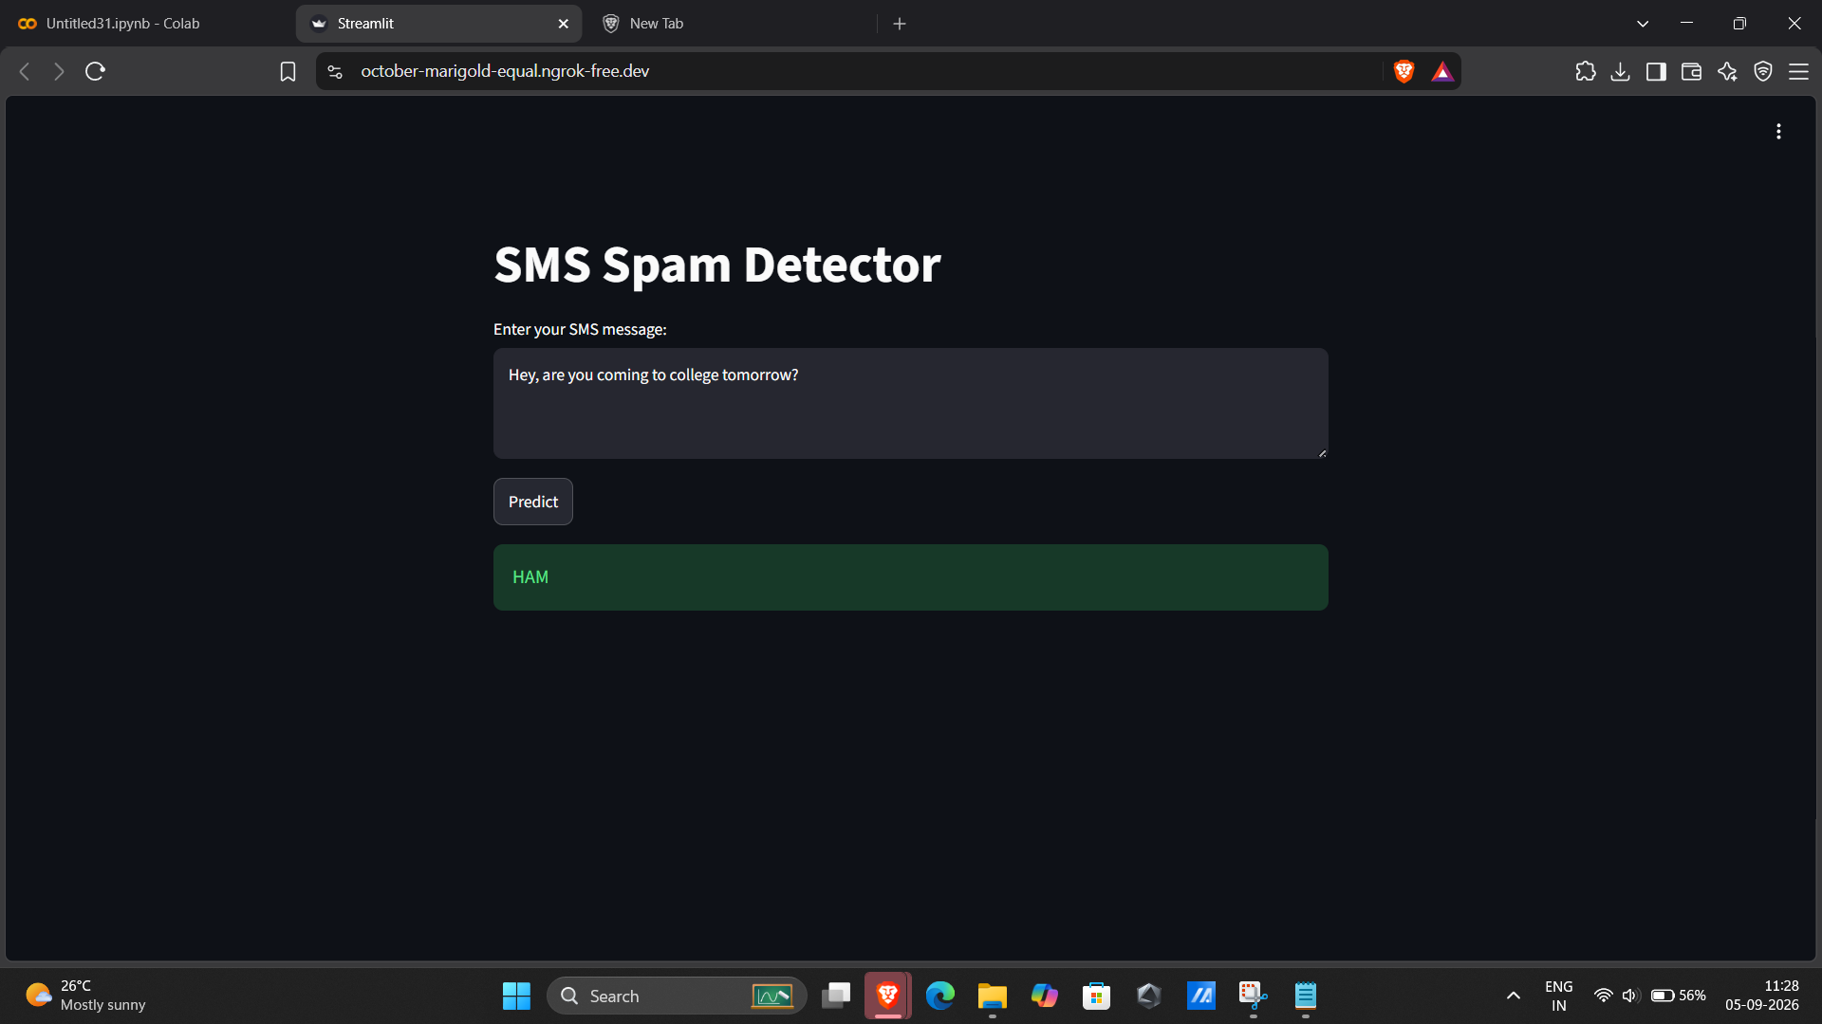
Figure 1: Streamlit application correctly classifying a legitimate SMS as HAM.

Application Screenshot 2 – SPAM Prediction
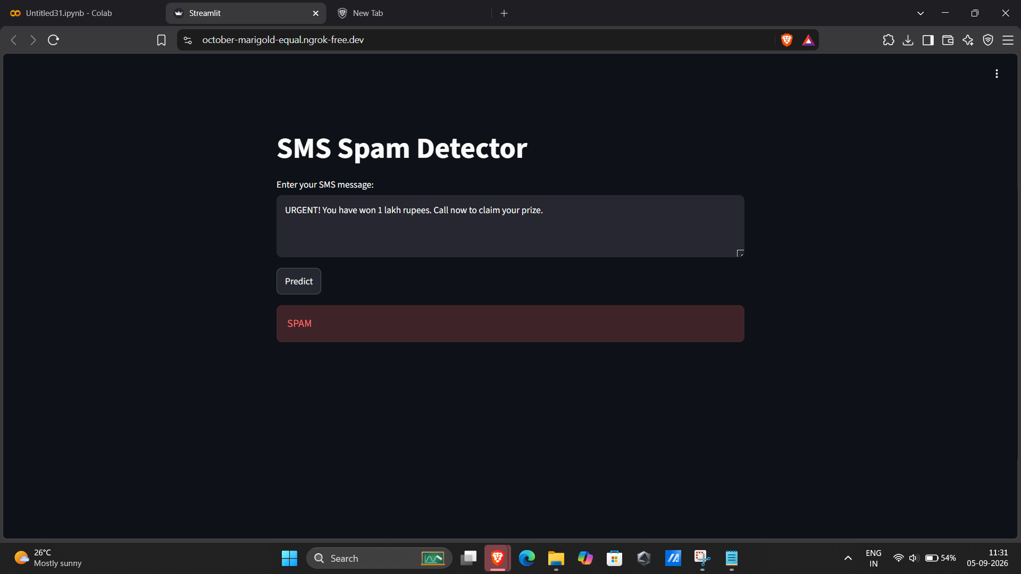
Figure 2: Streamlit application correctly classifying a prize-related SMS as SPAM.

